Skypark Arriving and Departing
- KBTF Arrivals:
  - Remain East of airport to avoid SLC Class B airspace
  - Useable KBTF Runway 4600 ft
IFR Weather:
- Follow SLC Approach path to Break off When KBTF in sight
VFR Weather:
- ATC request that you cancel IFR outside of SLC Class B airspace
  - South of FFU (Fairfield VOR)
  - North of OGD (Ogden VOR)
Please be familiar with SLC Class B airspace.
- KBTF Departures:
VFR Departures used
- Shoreline:
  - VPLGN (lagoon Amusement Park) then northwest along shoreline
  - Stay below SLC Class B or obtain Bravo Clearance
- Mountain Road:
  - VPLGN (Lagoon Amusement Park)
  - Climb North along the mountain road
  - NOTE: Be familiar with Class B airspace
- Southbound:
  - Remain East and clear of Class B airspace, or
  - Contact SLC Tower on 120.2 for Class B Transition
Please be familiar with SLC Class B airspace.
IFR Departures:
  - SL TRACON Flow Control: 801-325-9672
  - SL Clearance Delivery on 120.7

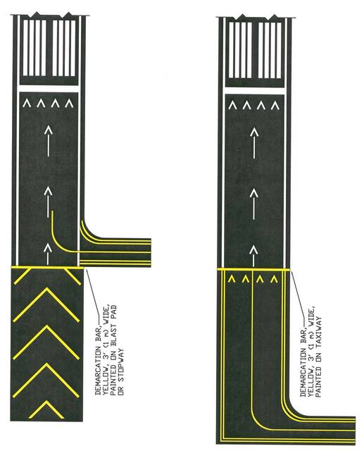Runway 17-35 Takeoff Procedures
DO NOT USE TAKOFF POWER UNTIL PAST YELLOW TRESHOLD

